

Speeds -> velocities



Behind -> before

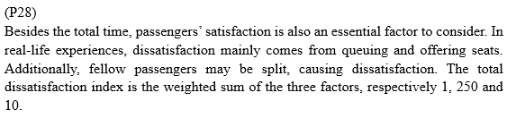

第三行第一句改成 ...and the standard variance of same-row passengers